**Business Intelligence – DWH Offering Analysis**

**Marium Jamal – 14881**

**Selected Platform:**

Azure: <https://azure.microsoft.com/en-us/resources/videos/introduction-to-azure-sql-data-warehouse/>

1. **How are they doing DWH (star schema, other formats etc.?)**

The main goal of DWH is to organize large amount of data in a presentable format that can be used to solve a business problem through multiple queries. Azure SQL data warehouse is built right on top of [Azure Blob Storage](https://azure.microsoft.com/en-us/services/storage/blobs/) which is Microsoft’s massive unstructured storage repository that provides you with a single SQL based view across the entire data whether relational or non-relational. This DWH decouples compute & storage i.e., it allows the users to load their entire data on one platform but charges for computation only.

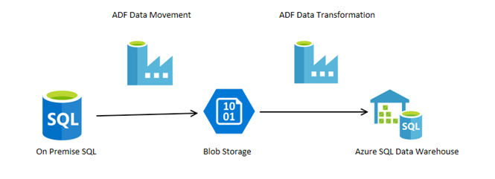

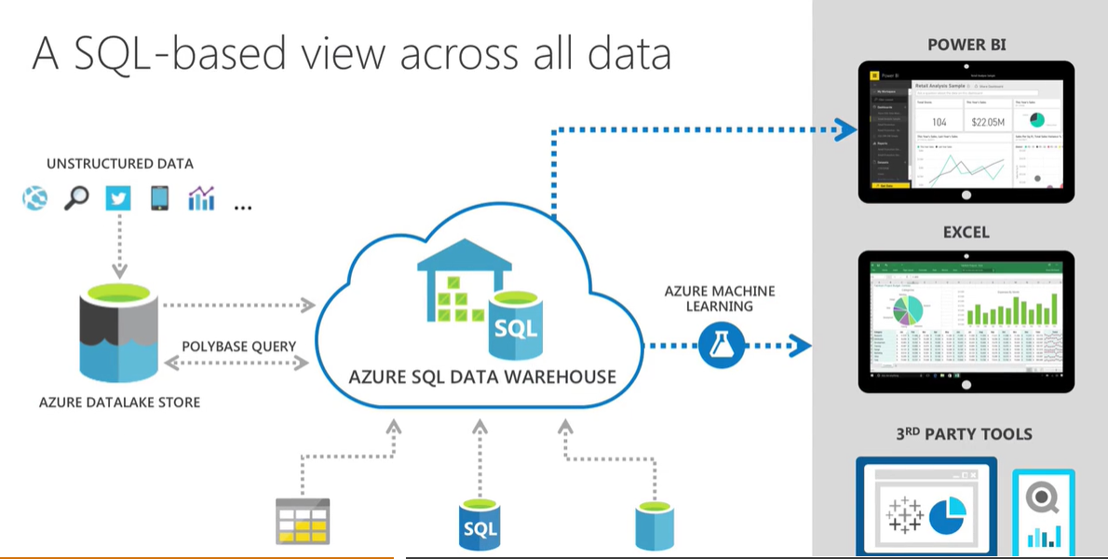

1. **Is some level of BI integrated within this tool? If yes, what are the features of this BI offering?**

Yes, recently Azure SQL Data Warehouse is combined with Power BI which works as a powerful data visualization tool and provides users with the ability to see insights of their data stored in Azure SQL Data Warehouse. Connecting both Power BI and Azure SQL Data Warehouse is easy because you can connect Power BI directly to the data stored in Azure SQL Data Warehouse, minimizing the need to upload data separately into Power BI

Some of the most common and promising features of Power BI are:

* Dataset filtration
* Customizable Dashboards
* DAX Data Analysis Function
* Ad Hoc Reporting
* Ad Hoc Analysis

